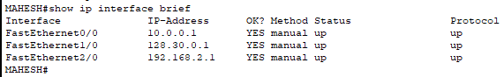
Fig: Router Intefaces

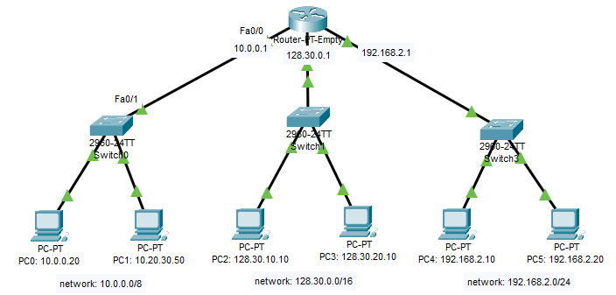
Fig: Topology of Class A, B and C Network

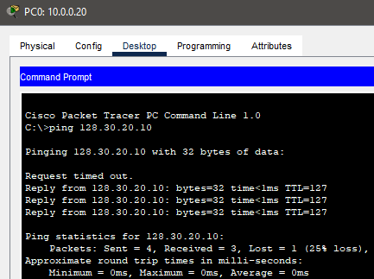
Fig: Testing connection from pc0 to pc3

